**Product Launching**

**BBA 2nd SEM (2022-23)**

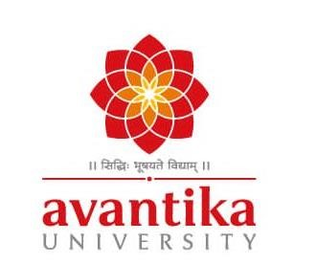

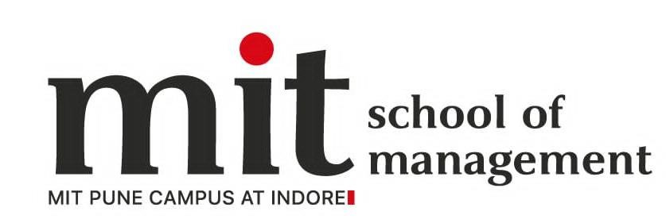

**Submitted By- Submitted To-**

Shankh Bansal Dr. Ankur Rastogi

AU22C1013

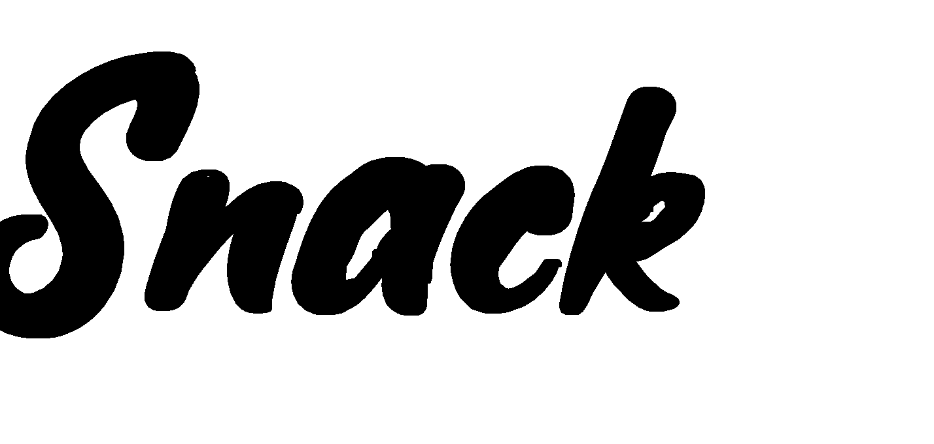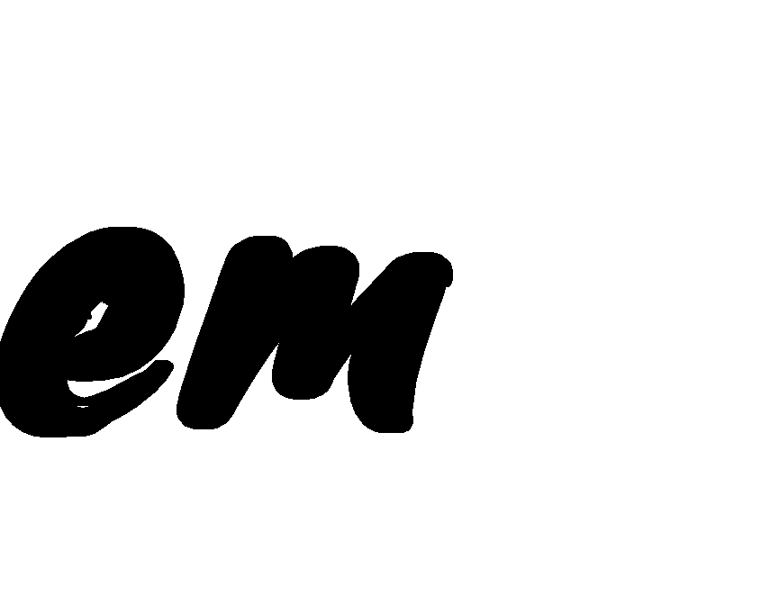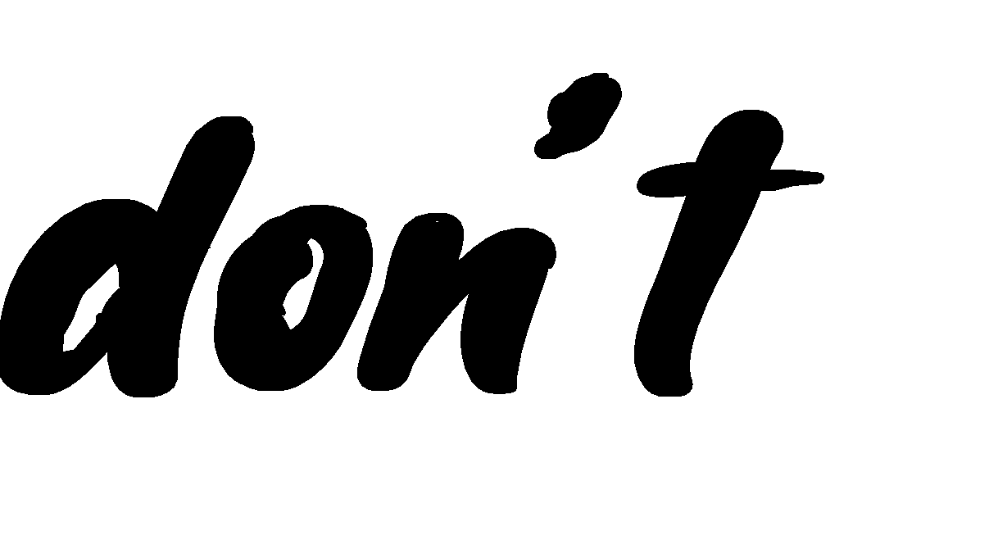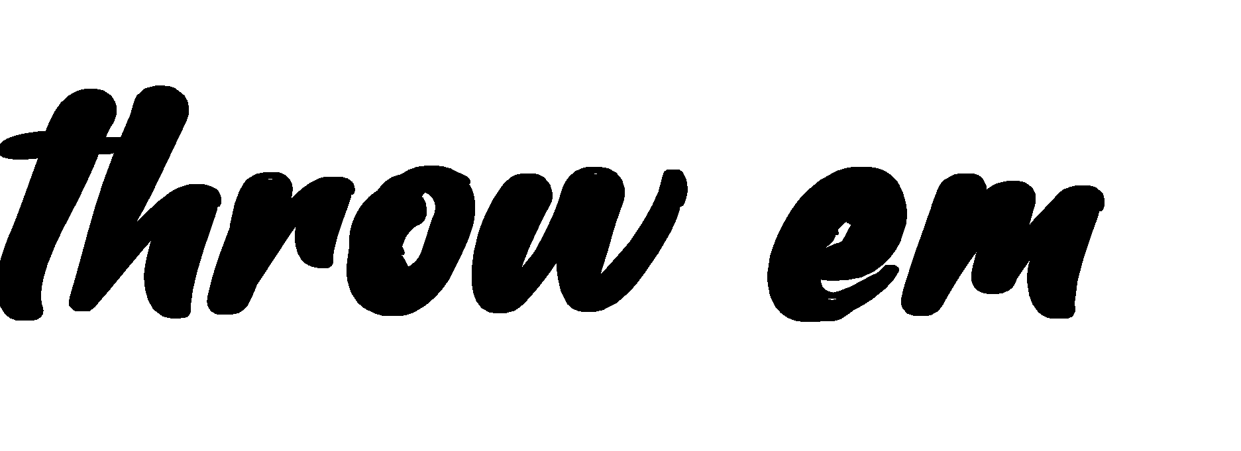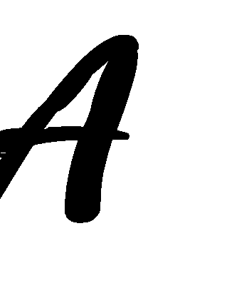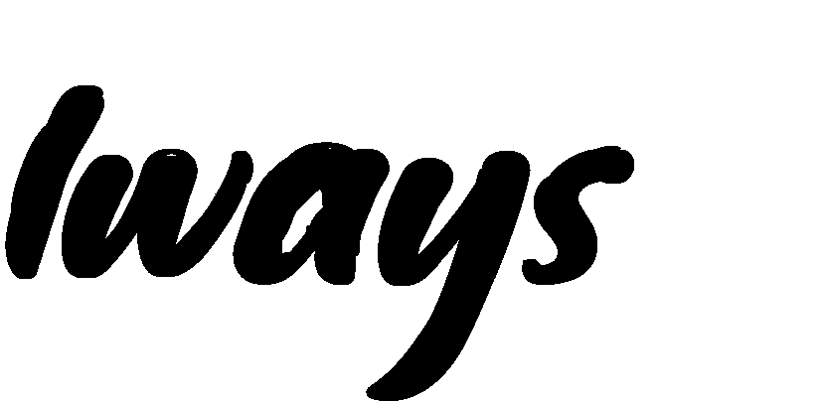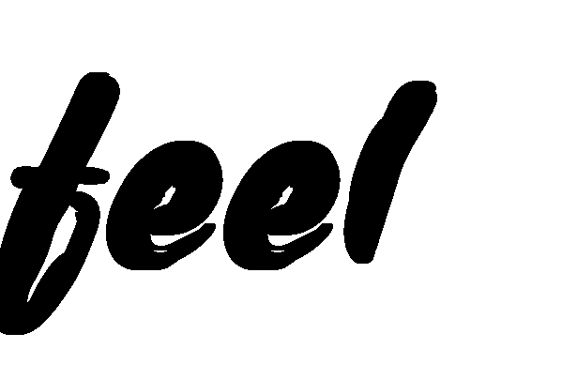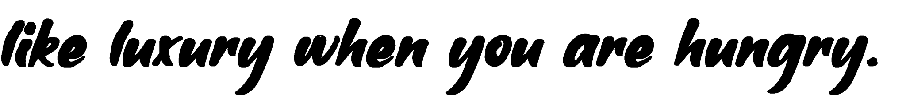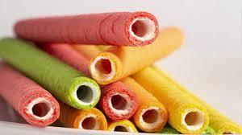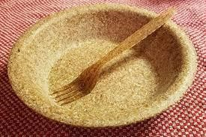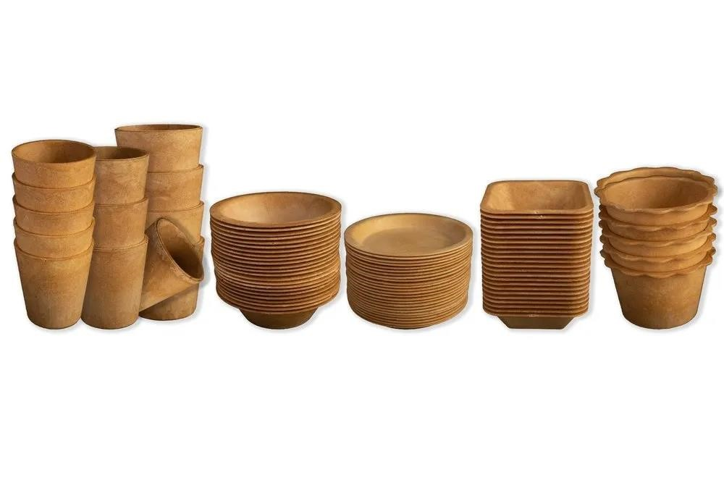

Who

needs food when you can eat cutlery

Eat in style

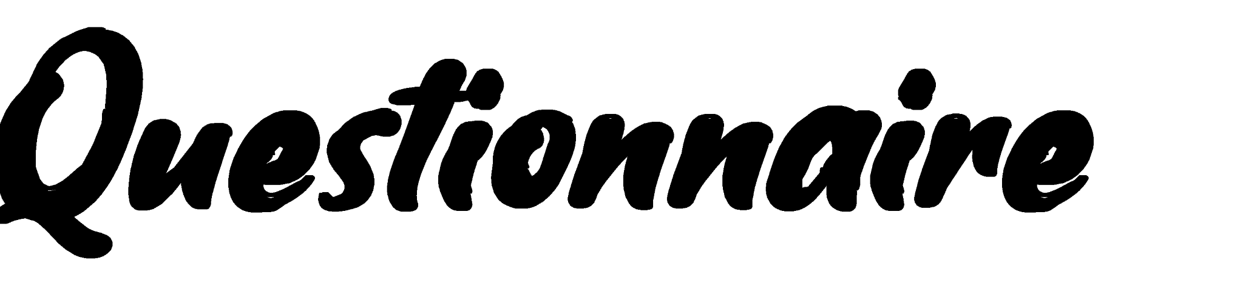

* Name -
* Age -
* Gender -

• Designation -

* Contact no. -

Q1) what are your goals for the next 1-5 years?

1. Establish yourself as a (city/state/national/international brand) Q2) who is the audience?

1. Children
2. Teenagers
3. Adult

Q3) what are your audience’s pain points?

1. Price
2. Quantity
3. Quality
4. Packaging

Q4) who is your end user?

1. Customer
2. Consumer
3. Wholesaler
4. Distributer

Q5) what are the standards for your product?

1. Cheap but best
2. Affordable to everyone
3. Strong distribution

Q6) what are the safety constraints?

1. Safe implementation technology
2. Safe design feature
3. Safe work for labours

Q7) is your product truly one-of-a-kind?

1. Yes
2. No

Q8) what is the estimated lifespan of the product?

1. 1 month
2. 3 months
3. 6 months
4. 12 months

Q9) what current and future technologies are people talking about?

1. Innovation
2. Simplicity
3. Usability

Q10) what is your business model?

1. Drive value
2. Create value
3. Capture value

Q11) what should it cost?

1. 2rs
2. 5rs
3. 10rs

Q12) who will sell the product?

1. Distributer
2. Whole seller

Q13) where will this product sells the most?

1. Restaurants
2. Café
3. Hotels

Q14) what will be the USP of your product?

1. Eatable
2. Design
3. Pricing

Q15) Do you think that this product will be a successful product?

1. Yes
2. No

Q16) which will be the best seller?

1. Cups
2. Plates
3. Cutlery